# Get data: ***25 Inclass Animated Maps annotated with snippets***

library(gapminder)

# Load libraries:

library(ggplot2)

library(gganimate)

library(gifski) # for gif output

# Note: I had to restart R after installing the packages before it would work and display the graphs.

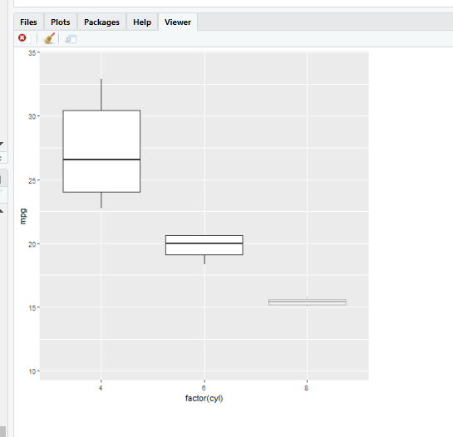# Somewhat contrived example, but useful to see how to animate

ggplot(mtcars, aes(factor(cyl), mpg)) +

geom_boxplot() +

# Here comes the gganimate code

transition_states(  ***#this is for discrete vars. Could be transition_time***

gear,

transition_length = 2, #this will help slow-mo

state_length = 1 ***#this will help slow-mo***

) +

enter_fade() +

exit_shrink() +

ease_aes('sine-in-out') ***#smooths the transition***

# Make a ggplot, but add frame=year: one image per year

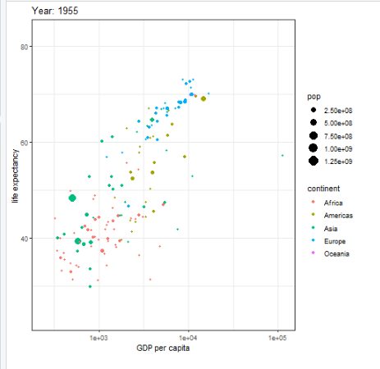ggplot(gapminder, aes(gdpPercap, lifeExp, size = pop, color = continent)) +

geom_point() +

scale_x_log10() +

theme_bw() +

# gganimate specific bits:

labs(title = 'Year: {frame_time}', x = 'GDP per capita', y = 'life expectancy') +

***#year shows in a counter window in top left***

transition_time(year) + ***#this is the increment / sequence***

ease_aes('linear')

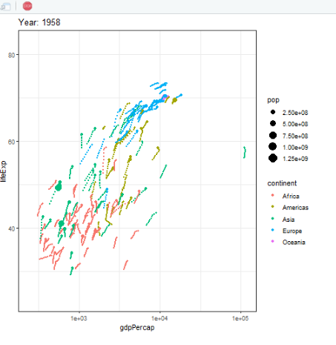

# Show preceding frames with gradual falloff

ggplot(gapminder, aes(gdpPercap, lifeExp, size = pop, color = continent)) +

geom_point() +

scale_x_log10() +

theme_bw() +

transition_time(year) +

labs(title = "Year: {frame_time}") +

shadow_wake(wake_length = 0.1, alpha = FALSE)

***#leaves a tail could be a fading tail***

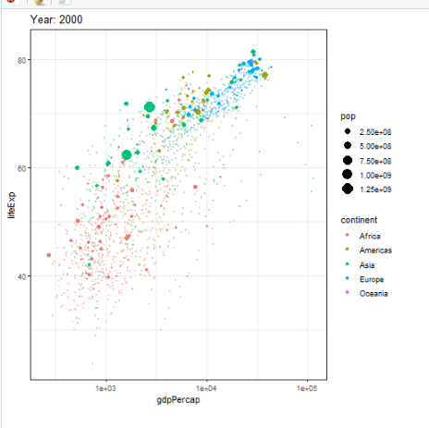# Show original data as background marks

ggplot(gapminder, aes(gdpPercap, lifeExp, size = pop, color = continent)) +

geom_point() +

scale_x_log10() +

theme_bw() +

transition_time(year) +

labs(title = "Year: {frame_time}") +

shadow_mark(alpha = 0.3, size = 0.5)

***#this leaves a mark, but smaller and faded, for previous occurrences***

# Save as gif:

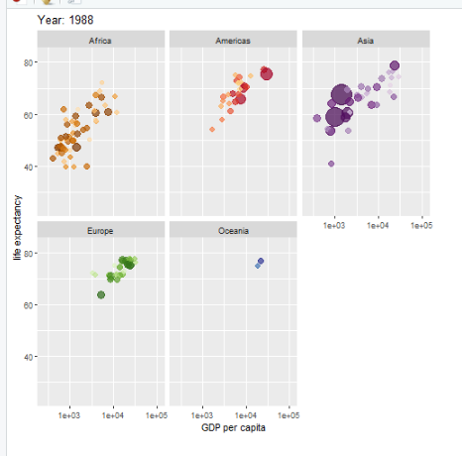anim_save("MyAnnimate.gif")

# another example

ggplot(gapminder, aes(gdpPercap, lifeExp, size = pop, colour = country)) +

geom_point(alpha = 0.7, show.legend = FALSE) +

scale_colour_manual(values = country_colors) +

scale_size(range = c(2, 12)) +

scale_x_log10() +

facet_wrap(~continent) + ***#can be faceted, with distinct colors***

# Here comes the gganimate specific bits

labs(title = 'Year: {frame_time}', x = 'GDP per capita', y = 'life expectancy') +

transition_time(year) +

ease_aes('linear')

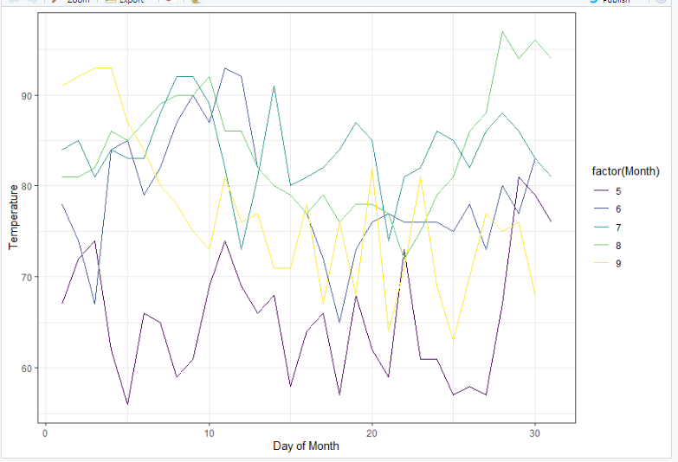# We can also gradually reveal the data

## static plot

p <- ggplot(

airquality,

aes(Day, Temp, group = Month, color = factor(Month))

) +

geom_line() +

scale_color_viridis_d() +

labs(x = "Day of Month", y = "Temperature") +

theme(legend.position = "top") +

theme_bw()

p

## animated plot

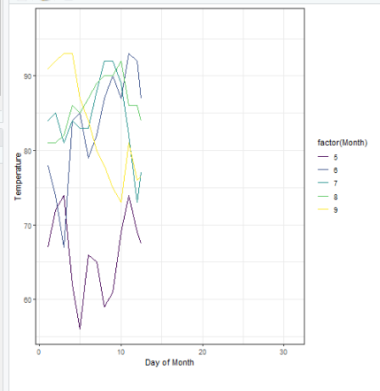p + transition_reveal(Day) ***#reveals in left to right pass***